DBMS
UNIT – 5
Q. Explain the CAP theorem referred during the development of any distributed application.
The CAP theorem is a fundamental principle in the development of distributed applications that addresses a crucial trade-off between three key properties: Consistency, Availability, and Partition Tolerance.
It states that any distributed system can only guarantee two out of these three properties simultaneously when a network partition occurs.
The Three Properties of CAP
- Consistency (C): Every client reading data receives the most recent written data. All nodes in the distributed system have the same, up-to-date view of the data at any given moment.
- Availability (A): Every request receives a (non-error) response, without the guarantee that the response contains the most recent write. The system remains operational and responsive to clients even if some individual nodes fail.
- Partition Tolerance (P): The system continues to operate despite arbitrary message loss or failure of parts of the system (a "network partition"). Network partitions are cannot avoided in real-world distributed systems (due to network outages, node failures, etc.) and thus, this property is considered a mandatory requirement for any truly distributed application.
When developing a distributed application, the CAP theorem forces you to make a conscious design decision based on your application's specific needs:
- For applications where data accuracy is paramount (e.g., banking systems), a CP model is typically chosen.
- For applications where continuous operation and responsiveness are more critical than having the absolute latest data immediately (e.g., social media feeds, e-commerce sites), an AP model with eventual consistency is preferred.
Q. Explain the NOSQL database types with examples and write down the real time applications.
NoSQL databases, or "not only SQL" databases, offer flexible schemas and horizontal scalability, making them suitable for handling large volumes of diverse data and high user loads. They are categorized into four main types:
1. Key-Value Stores:
- Description: This is the simplest NoSQL model, storing data as unique key-value pairs. The key acts as a unique identifier, and the value can be any data type (string, JSON, object, etc.).
- Example: Redis, Amazon DynamoDB (can also be used as a document store).
- Real-time Applications: Caching, session management, leaderboards, real-time analytics.
2. Document-Oriented Databases:
- Description: Data is stored in flexible, semi-structured "documents," often in JSON or BSON format. These documents can have varying structures, making them ideal for managing evolving data.
- Example: MongoDB, CouchDB.
- Real-time Applications: Content management systems, product catalogs, user profiles, e-commerce platforms, chat applications.
3. Column-Family Stores (Wide-Column Databases):
- Description: Data is organized into rows and dynamic columns, grouped into "column families." This model excels at handling vast amounts of data distributed across multiple servers and is optimized for efficient data retrieval in analytical scenarios.
- Example: Apache Cassandra, HBase.
- Real-time Applications: Big data analytics, IoT data processing, time-series data, recommendations engines.
4. Graph Databases:
- Description: Data is represented as nodes (entities) and edges (relationships between entities). This model is highly effective for applications requiring complex relationship analysis.
- Example: Neo4j, Amazon Neptune.
- Real-time Applications: Social networks, fraud detection, recommendation engines, knowledge graphs, network security.
Real-time Applications of NoSQL Databases:
NoSQL databases are widely used in real-time applications due to their ability to handle high throughput, low latency, and flexible data models. Examples include:
- Real-time analytics: Processing and analyzing large streams of data for immediate insights (e.g., fraud detection, personalized recommendations).
- Caching: Storing frequently accessed data in memory for rapid retrieval, improving application performance.
- Content delivery: Managing and serving dynamic content in web and mobile applications.
- Gaming: Storing player data, leaderboards, and session information for online games.
- IoT applications: Ingesting and processing sensor data from connected devices.
- Social media platforms: Managing user profiles, connections, and real-time interactions.

Q. Explain Structured, Semi-structured and Unstructured data types with examples.
1. Structured Data:
- Definition:
Highly organized data that conforms to a fixed schema or model, typically stored in tabular format with rows and columns. It has a well-defined structure and data types for each field.
- Examples:
Relational databases (e.g., SQL databases), Excel spreadsheets with defined columns like "Name," "Age," "Address," or "Product ID."
2. Semi-structured Data:
- Definition:
Data that possesses some organizational properties but does not strictly adhere to a rigid, predefined schema like structured data. It often uses tags or markers to separate semantic elements and enforce hierarchies.
- Examples:
JSON (JavaScript Object Notation) files, XML (Extensible Markup Language) documents, emails with defined headers (sender, recipient, subject) but free-form body text.
3. Unstructured Data:
- Definition:
Data that lacks a predefined schema or organization, making it difficult to store and analyze using traditional methods. It exists in its raw form without a clear internal structure.
- Examples:
Images, video files, audio recordings, plain text documents, social media posts, PDFs, emails (the body content itself).

Q. List the different NOSQL data models. Explain following NOSQL database types with examples. i) Column-oriented ii) Document-oriented
NoSQL databases encompass a diverse range of data models designed to address the limitations of traditional relational databases, particularly concerning scalability, flexibility, and handling unstructured or semi-structured data. The main types of NoSQL data models include:
- Key-Value Stores:
Data is stored as a collection of key-value pairs, where each unique key maps to a specific value.
- Document-Oriented Databases:
Data is stored in flexible, self-describing "documents," often in formats like JSON or XML.
- Column-Oriented (or Wide-Column) Databases:
Data is stored in columns rather than rows, optimizing for analytical queries and handling sparse data.
- Graph Databases:
Data is represented as nodes and edges, emphasizing relationships between entities.
Here's an explanation of the requested NoSQL database types:
i) Column-oriented Databases:
Column-oriented databases store data in columns, grouping all values for a specific attribute together. This contrasts with traditional row-oriented databases where all attributes for a single record are stored together. This structure is particularly efficient for analytical workloads and aggregate queries (e.g., SUM, COUNT, AVG), as it allows the database to read only the necessary columns, rather than entire rows.
Example:
Imagine a table storing website analytics data with columns like User ID, Page Visited, and Timestamp. In a column-oriented database, all User ID values would be stored together, all Page Visited values together, and so on. If you wanted to count the number of times a specific page was visited, the database would only need to access the Page Visited column, leading to faster query execution. Apache Cassandra and HBase are examples of column-oriented databases.
ii) Document-oriented Databases:
Document-oriented databases store data in flexible, semi-structured "documents." These documents are self-contained units that can hold various data types and structures, often using formats like JSON (JavaScript Object Notation) or XML. This model offers schema flexibility, allowing for easy evolution of data structures without requiring rigid schema changes.
Example:
Consider storing user profiles. In a document database, each user's profile could be a single document, containing fields like name, email, address, interests, and even nested arrays for friends or purchases.
Code
{
"userId": "user123",
"name": "Alice Smith",
"email": "alice@example.com",
"address": {
"street": "123 Main St",
"city": "Anytown",
"zip": "12345"
},
"interests": ["reading", "hiking"],
"friends": [
{"friendId": "user456", "name": "Bob Johnson"},
{"friendId": "user789", "name": "Charlie Brown"}
]
}
MongoDB and Couchbase are popular examples of document-oriented databases.

Q. Describe the following operations with MongoDB syntax:
i) Map-Reduce ii) Aggregation pipeline
i) Map-Reduce
Map-Reduce is a data processing paradigm for handling large datasets, involving a "map" phase and a "reduce" phase.
JavaScript
db.collection.mapReduce(
function map() {
// Defines the map function
emit(this.keyField, this.valueField);
},
function reduce(key, values) {
// Defines the reduce function
return Array.sum(values);
},
{
out: "outputCollection", // Specifies the output collection
query: { status: "A" }, // Optional: filters documents before mapping
sort: { orderDate: 1 }, // Optional: sorts documents before mapping
limit: 100 // Optional: limits the number of documents processed
}
);
- map() function:
Processes each input document, emitting key-value pairs. this refers to the current document being processed.
- reduce() function:
Receives a key and an array of values associated with that key, and combines them into a single result.
- out:
Specifies the collection where the results will be stored.
- query, sort, limit:
Optional parameters to filter, sort, or limit the input documents for the map-reduce operation.
ii) Aggregation Pipeline
The Aggregation Pipeline is a powerful framework in MongoDB for performing data transformations and aggregations through a series of stages.
JavaScript
db.collection.aggregate([
{
$match: { status: "A" } // Stage 1: Filters documents
},
{
$group: {
_id: "$customerId", // Groups documents by customerId
totalAmount: { $sum: "$amount" }, // Calculates the sum of 'amount' for each group
orderCount: { $count: {} } // Counts documents in each group
}
},
{
$sort: { totalAmount: -1 } // Stage 3: Sorts the results by totalAmount in descending order
},
{
$project: {
_id: 0, // Excludes the _id field
customer: "$_id", // Renames _id to customer
totalSales: "$totalAmount" // Renames totalAmount to totalSales
}
}
]);
- db.collection.aggregate([]): Initiates an aggregation pipeline on the specified collection.
- $match: Filters documents based on a specified condition.
- $group: Groups documents by a specified _id expression and applies accumulator operators (e.g., $sum, $count, $avg) to calculate aggregated values.
- $sort: Sorts the documents based on specified fields and order.
- $project: Reshapes documents, including or excluding fields, or adding new computed fields.
Note: While Map-Reduce exists, MongoDB recommends using the Aggregation Pipeline for most aggregation tasks due to its better performance and usability. For custom functionalities in aggregation, operators like $accumulator and $function can be used within the pipeline.
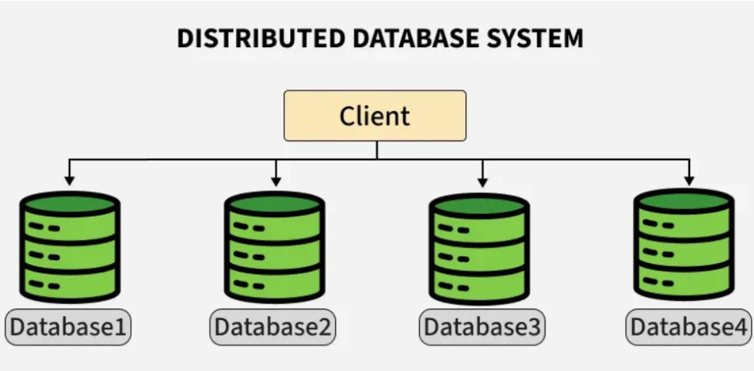
Q. Draw and explain architecture of Distributed database system. State the reasons for building distributed database systems.

Distributed database systems are built for high availability (no single point of failure), better performance (closer data, parallel processing), enhanced scalability (add nodes for growth), and to support geographically spread users with lower latency and local control, ensuring reliability and efficiency for modern complex applications. They spread data across multiple computers, appearing as one logical database, solving limitations of centralized systems.
Key Reasons for Building Distributed Databases:
- Reliability & Fault Tolerance: Data is replicated across nodes, so if one fails, others continue operating, preventing downtime and data loss.
- Scalability: Easily scale horizontally by adding more servers to handle increasing data and user loads, which is crucial for growing applications.
- Performance & Low Latency: Data can be stored closer to users (data locality), reducing network travel and speeding up response times.
- Data Sharing & Local Control: Enables data access across different locations while allowing local sites to manage their own data.
- Cost-Effectiveness: Can optimize resource use and sometimes lower communication costs compared to large centralized systems.
- Modular Growth: Allows organizations to grow their database capacity and performance incrementally as needed.
- Improved Performance (Parallelism): Distributes processing tasks across multiple nodes for faster execution of complex queries.
- Compliance & Residency: Helps meet data residency laws by storing data within specific geographic borders.
In essence, distributed systems overcome the bottlenecks and single points of failure inherent in centralized databases, making them ideal for global, high-demand scenarios in finance, e-commerce, and big dat
Types :
1. Client-Server Distributed Database System
In this model, the server stores and manages the database, while clients send queries over the network. It offers centralized control with distributed access, making it ideal for enterprise systems and web applications. Clients can be lightweight while the server handles heavy processing.
Example: Web application interacting with a central PostgreSQL server.
Features:
- Simplifies resource management.
- Central servers can be optimized for performance.
- Easily scalable with more clients.
Example: An e-commerce website where the frontend (client) is hosted separately and interacts with a central PostgreSQL server to manage orders, users, and inventory.
2. Peer-to-Peer Distributed Database System
Here, all nodes are equal, with no fixed client or server roles. Each node can store data and also process queries, leading to decentralized control. It supports fault tolerance and high availability. Example: Blockchain networks like Ethereum, where each node maintains a part of the distributed ledger.
Features:
- No single point of failure.
- Useful in decentralized and distributed apps.
- High availability and data redundancy.
Example: Blockchain-based databases like Ethereum or BitTorrent-based systems, where each peer maintains part of the ledger and participates equally in transactions.
3. Cloud-Based Distributed Database System
These systems are deployed on cloud platforms and span multiple geographic regions for scalability and reliability. They abstract infrastructure details and are offered as DBaaS, making them ideal for dynamic workloads. Example: Google Cloud Spanner and Amazon DynamoDB used for global applications.
Features:
- Automatic scaling and replication.
- Pay-as-you-use pricing.
- Global availability and disaster recovery.
Example:
- Google Cloud Spanner: Global-scale relational database.
- Amazon DynamoDB: Key-value and document database with high performance.
- Azure Cosmos DB: Multi-model, globally distributed DBMS.
4. Homogeneous Database:
In a homogeneous database, all different sites store database identically. The operating system, database management system, and the data structures used all are the same at all sites. Hence, they're easy to manage.
Features:
- Unified query language and interface.
- Low integration complexity.
- Efficient synchronization.
Example: A bank with branches in different cities uses Oracle DB at every location. All databases have the same structure and are synchronized regularly.
5. Heterogeneous Database
In a heterogeneous distributed database, different sites may use different DBMSs, schemas, or data models, making query processing and transactions difficult. Some sites may not even be aware of others, so translation mechanisms are needed for communication.
Features:
- Supports interoperability between diverse systems.
- Complex query optimization and transaction management.
- Useful in mergers or collaborations between organizations.
Example: A logistics company uses MySQL for inventory, MongoDB for vehicle tracking, and PostgreSQL for billing. Integration middleware allows unified querying across these platforms.

Q. Explain the difference between SQL and NOSQL database.
Aspect | SQL (Relational) | NoSQL (Non-relational)
Data Structure | Tables with rows and columns | Document-based, key-value, column-family, or graph-based
Schema | Fixed schema (predefined structure) | Flexible schema (dynamic and adaptable)
Scalability | Vertically scalable (upgrading hardware) | Horizontally scalable (adding more servers)
Data Integrity | ACID-compliant (strong consistency) | BASE-compliant (more available, less consistent)
Query Language | SQL (Structured Query Language) | Varies (e.g., MongoDB uses its own query language)
Performance | Efficient for complex queries and transactions | Better for large-scale data and fast read/write operations
Use Case | Best for transactional systems (banking, ERP, etc.) | Ideal for big data, real-time web apps, and data lakes
Examples | MySQL, PostgreSQL, Oracle, MS SQL Server | MongoDB, Cassandra, CouchDB, Neo4j

Q. Explain BASE Properties of NOSQL Database.
NoSQL databases often adhere to the BASE properties, an alternative to the ACID properties found in traditional relational databases. BASE stands for:
- Basically Available:
The system guarantees that the database will always be available for operations (reads and writes), even if some parts of the system experience failures. This prioritizes availability over immediate data consistency, meaning a request might receive a response that doesn't reflect the absolute latest state of the data.
- Soft State:
The state of the database can change over time, even without explicit input from an application. This is a consequence of eventual consistency and the distributed nature of NoSQL systems. Data might be in a temporary, inconsistent state as updates propagate across the system.
- Eventual Consistency:
While immediate consistency is not guaranteed, the system will eventually become consistent. If no new updates are made to a data item, all accesses to that item will eventually return the last updated value. There is no guarantee on the timeframe for this consistency to be achieved.
In essence, BASE properties prioritize high availability and scalability, particularly in distributed environments, by relaxing the strict consistency guarantees found in ACID

Q. Explain the CRUD operations used in MongoDB with example.
CRUD stands for Create, Read, Update, and Delete, representing the four fundamental operations for interacting with data in a database like MongoDB.
Create (Insert) Operations
Create operations add new documents to a collection.
- db.collection.insertOne(document): Inserts a single document into a collection.
- db.collection.insertMany([document1, document2, ...]): Inserts multiple documents into a collection.
Example:
JavaScript
db.products.insertOne({
name: "Laptop",
price: 1200,
category: "Electronics"
});
db.products.insertMany([
{ name: "Keyboard", price: 75, category: "Accessories" },
{ name: "Mouse", price: 25, category: "Accessories" }
]);
Read (Query) Operations
Read operations retrieve documents from a collection.
- db.collection.find(query): Retrieves documents matching the specified query. An empty query {} returns all documents.
- db.collection.findOne(query): Retrieves the first document matching the specified query.
Example:
JavaScript
db.products.find({}); // Find all products
db.products.find({ category: "Electronics" }); // Find products in 'Electronics' category
db.products.findOne({ name: "Laptop" }); // Find the product named 'Laptop'
Update Operations
Update operations modify existing documents in a collection.
- db.collection.updateOne(query, update): Updates a single document matching the query.
- db.collection.updateMany(query, update): Updates all documents matching the query.
- db.collection.replaceOne(query, replacementDocument): Replaces a single document matching the query with a new document.
Example:
JavaScript
db.products.updateOne(
{ name: "Laptop" },
{ $set: { price: 1150 } } // Update the price of 'Laptop'
);
db.products.updateMany(
{ category: "Accessories" },
{ $inc: { price: 5 } } // Increase price of all accessories by 5
);
Delete Operations
Delete operations remove documents from a collection.
- db.collection.deleteOne(query): Deletes a single document matching the query.
- db.collection.deleteMany(query): Deletes all documents matching the query.
Example:
JavaScript
db.products.deleteOne({ name: "Mouse" }); // Delete the product named 'Mouse'
db.products.deleteMany({ category: "Accessories" }); // Delete all products in 'Accessories' category
Q. Analyze the use of NOSQL databases in current social networking environment also explain need of NOSQL databases in social networking environment over RDBMS.
NoSQL databases are widely used in current social networking environments due to their ability to handle the unique challenges presented by these platforms.

Use of NoSQL in Social Networking:
- Graph Databases:
Graph databases like Neo4j are ideal for representing complex relationships, such as friendships, followers, and connections, which are central to social networks. This allows for efficient querying of social graphs and relationship-based recommendations.
- Document Databases:
Document databases like MongoDB are suitable for storing user profiles, posts, comments, and other dynamic, semi-structured content, offering flexibility in schema evolution.
- Key-Value Stores:
Key-value stores like Redis are employed for caching frequently accessed data, such as user sessions, news feed content, and real-time updates, ensuring high performance and responsiveness.
- Column-Family Databases:
Databases like Cassandra can handle large volumes of data with high write throughput, making them suitable for storing activity logs, message histories, and other time-series data.
Need for NoSQL over RDBMS in Social Networking:
- Scalability:
Social networks experience massive and unpredictable growth in users and data. NoSQL databases offer horizontal scalability, allowing for easy distribution of data across multiple servers to handle increasing loads, unlike the vertical scaling limitations of traditional RDBMS.
- Flexibility with Unstructured Data:
Social media data is often unstructured or semi-structured (e.g., user-generated content, diverse media types). NoSQL's schema-less nature provides the flexibility to store and manage this data without rigid predefined schemas.
- Performance:
Social networks demand high performance for real-time interactions, feed generation, and rapid data retrieval. NoSQL databases, optimized for specific data models and access patterns, can deliver superior performance compared to RDBMS, especially for read-heavy operations and large datasets.
- Handling Relationships:
While RDBMS uses joins to manage relationships, NoSQL graph databases are inherently designed for efficient traversal and querying of complex relationships, which is a core requirement for social graphs.
Q.Describe distributed database. Explain System architecture of distributed transaction.
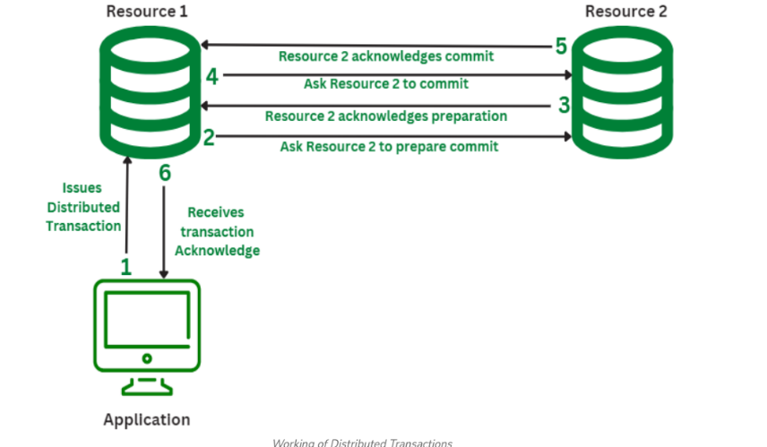
A distributed database system (DDBS) is a collection of logically interrelated databases distributed over a computer network. Data is physically stored in various locations but appears to end users as a single, cohesive database. This architecture aims to improve data availability, reliability, and performance by enabling local access, parallel processing, and fault tolerance.

System Architecture of a Distributed Transaction
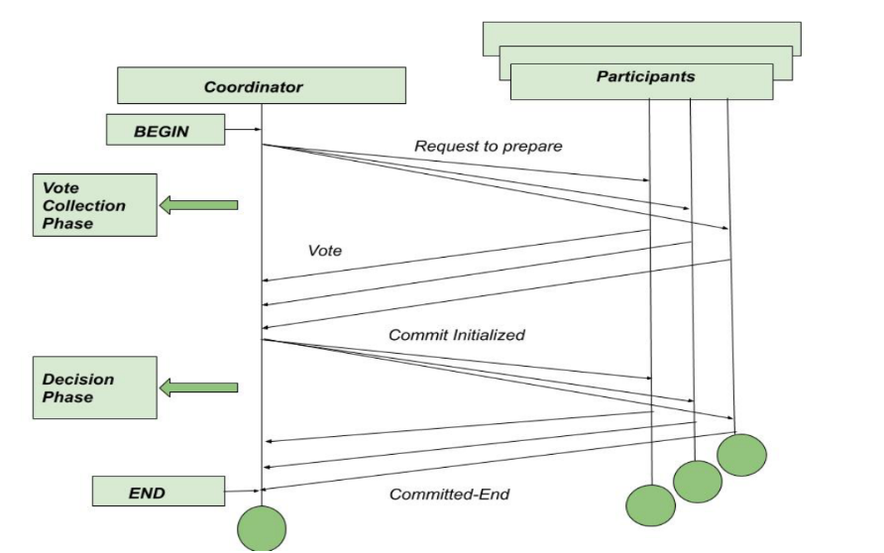
A distributed transaction involves operations on data spread across multiple distinct data repositories, typically databases on different nodes connected by a network. The primary mechanism for ensuring atomicity (all-or-nothing property) in distributed transactions is the Two-Phase Commit (2PC) protocol.

The architecture of a distributed transaction using 2PC typically involves:
- Transaction Coordinator (or Global Transaction Manager):
  - This component initiates and manages the distributed transaction.
  - It communicates with all participating local transaction managers (cohorts) to coordinate the commit or abort of the transaction.
  - It maintains the state of the transaction throughout the 2PC process.
- Local Transaction Managers (or Cohorts):
  - Each database or data repository involved in the distributed transaction has a local transaction manager.
  - This manager interacts with its local database to perform the operations requested by the distributed transaction.
  - It responds to commands from the transaction coordinator, indicating its readiness to commit or its decision to abort.
The Two-Phase Commit protocol operates in two phases:
Phase 1: Prepare Phase
- The transaction coordinator sends a "prepare" message to all local transaction managers involved in the distributed transaction.
- Each local transaction manager performs the necessary operations (e.g., locking resources, writing to a log) to prepare for a potential commit.
- If a local transaction manager can successfully prepare, it sends a "vote-commit" message to the coordinator. If it encounters an issue, it sends a "vote-abort" message.
Phase 2: Commit/Abort Phase
- The transaction coordinator collects the votes from all local transaction managers.
  - If all votes are "vote-commit": The coordinator sends a "global commit" message to all local transaction managers. Each local manager then commits its local transaction and releases resources.
  - If any vote is "vote-abort": The coordinator sends a "global abort" message to all local transaction managers. Each local manager then rolls back its local transaction and releases resources.
- Upon receiving the commit or abort message, each local transaction manager acknowledges the action to the coordinator.
This architecture ensures that either all participants in the distributed transaction commit their changes or all of them abort, maintaining data consistency across the distributed system.

Unit - 6

Q. What is the significance of XML databases? Explain with example the use of XML databases.
Significance of XML Databases:
- Handling Hierarchical and Semi-structured Data:
XML's inherent tree structure makes it ideal for storing data with nested elements and varying schemas, unlike rigid relational databases.
- Data Interchange and Web Integration:
XML is a widely accepted standard for data exchange in web services (SOAP, REST), making XML databases crucial for seamless communication between diverse systems.
- Self-Describing Data:
XML tags provide context and meaning to the data, enhancing readability and facilitating understanding without external schema definitions.
- Flexibility and Evolving Schemas:
XML's flexible nature allows for easy modification and evolution of data structures, accommodating changes in data requirements without significant database overhauls.
- Powerful Querying:
Languages like XQuery and XPath enable powerful, path-based querying and transformation of XML data, allowing for complex data retrieval and manipulation.
Example Use of XML Databases:
Consider a product catalog where each product can have varying attributes (e.g., a book has an author and ISBN, a shirt has size and color).
Code
<products>
<product id="101">
<name>The Great Gatsby</name>
<category>Book</category>
<author>F. Scott Fitzgerald</author>
<isbn>978-0743273565</isbn>
<price>10.99</price>
</product>
<product id="102">
<name>Blue T-Shirt</name>
<category>Apparel</category>
<size>M</size>
<color>Blue</color>
<material>Cotton</material>
<price>19.99</price>
</product>
</products>
Use Case: Storing and querying this product catalog in an XML database.
Example Query (XQuery): To find all books in the catalog:
Code
for $product in /products/product
where $product/category = "Book"
return $product/name

Q. What is Deductive Database. Explain its features and state its advantages over traditional database.
A deductive database is a database system that combines features of relational databases with logic programming. It stores not only explicit facts but also a set of rules that allow the system to deduce new, implicit facts. Datalog is a common language used to define these facts, rules, and queries in deductive databases.
Features of Deductive Databases:
- Facts and Rules:
They store explicit facts, similar to tuples in relational databases, and a set of logical rules (often expressed in Datalog) that define how new facts can be inferred from existing ones.
- Inference Engine:
A core component that applies the rules to the stored facts to derive new information, essentially performing logical reasoning.
- Recursion:
A key feature distinguishing them from traditional relational databases is their native support for recursive queries, enabling the definition of complex relationships like "ancestor" or "part-of" hierarchies.

- Declarative Nature:
Queries and rules are expressed declaratively, focusing on what needs to be retrieved or inferred rather than how the process should occur.
- Integration of Logic Programming:
They bridge the gap between relational databases and logic programming languages like Prolog, offering a more expressive query language than SQL while maintaining database management capabilities.
Advantages over Traditional Databases:
- Enhanced Expressive Power:
Deductive databases can handle complex recursive queries and relationships that are difficult or impossible to express efficiently in standard SQL, especially in older versions.
- Reduced Data Redundancy:
Implicit facts can be derived from rules, eliminating the need to explicitly store all possible combinations of data, thus reducing storage requirements and potential for inconsistencies.
- Improved Data Consistency and Integrity:
Rules can act as powerful integrity constraints, automatically enforcing consistency and ensuring that derived facts adhere to the defined logic.
- Simplified Querying of Complex Data:
For applications involving hierarchical data, network structures, or intricate relationships, the rule-based approach of deductive databases can simplify query formulation.
- Support for Knowledge Representation:
They are well-suited for applications requiring knowledge representation and reasoning, such as expert systems, data integration, and semantic web applications.

Q. Write a short note on complex data types: i) Semi-structured data ii) Features of semi-structured data modeles
Complex Data Types: Semi-structured Data
Semi-structured data represents a category of data that possesses some organizational properties but does not strictly conform to the rigid, tabular structure of traditional relational databases. It occupies a middle ground between completely unstructured data (like raw text documents or images) and fully structured data (like data stored in SQL tables).

Features of the Semi-structured Data Model:
- Flexible Schema:
Unlike structured data with a predefined and rigid schema, semi-structured data allows for a more flexible and evolving schema. Attributes can be optional or vary across instances of the same data entity.
- Self-Describing:
Metadata, such as tags or keys, is embedded within the data itself, making it self-describing. This eliminates the need for a separate schema definition and aids in understanding the data's structure and content.
- Hierarchical Nesting:
Semi-structured data models often support hierarchical structures, allowing for the nesting of objects, arrays, or sub-documents within other data elements. This facilitates the representation of complex relationships..
- Extensibility:
The flexible nature of semi-structured data makes it easily extensible. New fields or attributes can be added without requiring extensive schema migrations or changes to existing data.
- Partial Data Tolerance:
Semi-structured data models naturally accommodate “its ok , missing values or incomplete data”, as attributes are not always mandatory or present in every instance.
- Irregular Relationships:
These models can represent various types of relationships, including one-to-many and many-to-many, in a more fluid manner compared to the strict relational model.
- Loose Typing:
While data types are generally inferred or indicated, the enforcement of strict data types can be less rigid than in structured data, allowing for some flexibility in value types.
- Queryability:
Despite the lack of a rigid schema, semi-structured data can be queried using specialized tools and languages, such as XPath for XML or JSONPath for JSON, enabling the retrieval and manipulation of specific data elements.
Examples: Common examples of semi-structured data include XML documents, JSON objects, log files, and data exchanged via APIs. These formats are widely used in web development, data interchange, and various applications where flexibility and adaptability are crucial.

Q. Explain how encoding and decoding of JSON object is done in JAVA with example.
In Java, encoding (serialization) and decoding (deserialization) of JSON objects typically involve using a JSON library like json-simple, Jackson, or Gson. This explanation focuses on the json-simple library for its simplicity.
1. Encoding (Serialization): Converting Java Objects to JSON String
The process of converting a Java object (like a Map or a custom class) into a JSON string is called encoding or serialization.
- Theoretical Concept: You create a JSONObject and populate it with key-value pairs, similar to how you would populate a Map. The JSONObject then provides methods to convert itself into a JSON formatted string.
- Short Example:
Java
import org.json.simple.JSONObject;
import java.util.HashMap;
import java.util.Map;
public class JsonEncodingExample {
public static void main(String[] args) {
Map<String, Object> dataMap = new HashMap<>();
dataMap.put("name", "Alice");
dataMap.put("age", 30);
dataMap.put("isStudent", false);
JSONObject jsonObject = new JSONObject(dataMap);
String jsonString = jsonObject.toJSONString();
System.out.println("Encoded JSON: " + jsonString);
}
}
2. Decoding (Deserialization): Converting JSON String to Java Objects
The process of converting a JSON string back into a Java object (like a Map or a custom class) is called decoding or deserialization.
- Theoretical Concept: You use a JSONParser to parse the JSON string. The parser then provides methods to access the data within the JSON structure, typically as JSONObject or JSONArray objects, which can then be cast to Java Map or List types.
- Short Example:
Java
import org.json.simple.JSONObject;
import org.json.simple.parser.JSONParser;
import org.json.simple.parser.ParseException;
public class JsonDecodingExample {
public static void main(String[] args) {
String jsonString = "{\"name\":\"Bob\",\"age\":25,\"isStudent\":true}";
JSONParser parser = new JSONParser();
try {
JSONObject jsonObject = (JSONObject) parser.parse(jsonString);
String name = (String) jsonObject.get("name");
long age = (Long) jsonObject.get("age"); // Note: json-simple parses numbers as Long
boolean isStudent = (Boolean) jsonObject.get("isStudent");
System.out.println("Decoded Name: " + name);
System.out.println("Decoded Age: " + age);
System.out.println("Decoded Is Student: " + isStudent);
} catch (ParseException e) {
e.printStackTrace();
}
}
}
Key Points:
- Dependencies:
You need to include the json-simple library (or your chosen JSON library) in your project's dependencies.
- Error Handling:
When decoding, always handle ParseException as the JSON string might be malformed.
- Type Casting:
Be mindful of the data types when retrieving values from a JSONObject, as you often need to cast them to the appropriate Java types.

Q. What are spatial data. Explain Geographic and Geometric data.
Spatial data describes locations and shapes on Earth, encompassing both geographic data (latitude/longitude, real-world coordinates) and geometric data (points, lines, polygons defining shapes). Geographic data links features to Earth's surface (e.g., a city's location), while geometric data provides the actual shape (e.g., the outline of that city as a polygon). Together, they form the basis for maps and GIS, allowing us to visualize and analyze real-world features like roads, buildings, and boundaries.
Spatial Data
- Definition: Data that represents features, objects, or phenomena in physical space, often directly or indirectly referencing a specific location on Earth.
- Components: Includes geometry (shape/location), topology (spatial relationships), and attributes (descriptive data like name, population).
- Examples: Maps, floor plans, GPS points, satellite imagery.
Geographic Data
- Focus: Relates features to the Earth's curved surface using angular (latitude/longitude) or linear units.
- Purpose: Establishes the real-world location and context for spatial data.
- Examples: GPS coordinates (e.g., 34.0522° N, 118.2437° W), elevation data, satellite navigation system data.
Geometric Data
- Focus:
Defines the shape and structure of features in a mathematical or coordinate system (like flat X,Y planes or curved spheres).
- Purpose:
Models the physical form of features, independent of their specific Earth location.
- Examples:
  - Points: A single dot (e.g., a subway station).
  - Lines (LineStrings): Paths or connections (e.g., roads, rivers).
  - Polygons: Enclosed areas (e.g., city boundaries, lakes)

Q. What is object relational database system. Explain Table inheritance with example.
An Object-Relational Database System (ORDBMS) is a database management system that bridges the gap between traditional relational databases and object-oriented concepts, integrating features from both [1]. It provides a rich data model that allows developers to define complex objects with inheritance, while still using the familiar SQL interface to manage data [1].
Object-Relational Database System (ORDBMS)
An ORDBMS is defined by the following key characteristics:
- Extended Data Types: Unlike traditional relational databases which are limited to simple types (like integers and strings), ORDBMS allows users to define custom, complex data types, such as geospatial data, multimedia objects (images, audio), or structured documents [1, 2].
- Encapsulation and Methods: Objects in an ORDBMS can encapsulate both data (attributes) and behavior (methods or functions) that operate on that data [1]. These methods are defined within the database schema itself.
- Inheritance: It supports object-oriented principles like inheritance, allowing for the creation of type hierarchies where new types (subtypes) inherit attributes and behaviors from existing types (supertypes) [1, 2].
- Complex Relationships: It handles complex relationships and object nesting more naturally than purely relational systems, where such relationships often require complicated joins [2].
- SQL Compatibility: ORDBMS maintains the use of SQL as its primary query language, often with extensions to handle the new object-oriented features [1].
Table Inheritance
Table inheritance is a feature that allows a database table to inherit the structure and properties of another table, mirroring the concept of class inheritance in object-oriented programming [1].
Key aspects of table inheritance:
- Structure Sharing: A child table automatically includes all the columns of its parent table [3].
- Data Access: Queries on the parent table can often access data stored in both the parent and all its child tables, providing a unified view [1].
- Specialization: Child tables can define additional columns unique to their more specialized purpose [3].
Example of Table Inheritance (using PostgreSQL syntax)
Consider a university database that needs to store information about different types of employees: general staff, full-time professors, and adjunct professors. All employees share basic information like name and email, but professors also have a department, and full-time professors have a tenure_status.
Here is how you might implement this using table inheritance:
- Create a Child Table (Subtype) that inherits from employees:
sql
CREATE TABLE professors (
department VARCHAR(100)
) INHERITS (employees);
The professors table now automatically has employee_id, name, and email columns, plus its specific department column.

Q. Write a short note on emerging databases : i) Active and Deductive Databases ii) Main Memory Databases
i) Active and Deductive Databases
- Active Databases: These are event-driven systems that can automatically respond to events occurring inside or outside the database without intervention from external applications. Their behavior is defined by Event-Condition-Action (ECA) rules: when a specific event (e.g., data insertion, time passing, sensor reading) occurs, the system evaluates a condition, and if the condition is true, it executes a defined action.
  - Purpose: Enhances traditional database functionality with powerful rule processing capabilities, enforces complex integrity constraints, and provides a centralized way to manage business rules.
  - Applications: Real-time monitoring (e.g., power plants, stock trading, air traffic control), security monitoring, and alert systems.
- Deductive Databases: These systems extend traditional relational databases by integrating logic programming capabilities, allowing the system to infer new facts from existing data and a set of logical rules. They typically use languages like Datalog to specify facts (extensional database) and rules (intensional database) in a declarative manner.
  - Purpose: Enables complex queries, especially recursive ones (e.g., finding all ancestors of a person), which are difficult or impossible to express efficiently in standard SQL.
  - Applications: Artificial intelligence, expert systems, data integration, and network analysis, where complex data relationships and automated reasoning are needed.
ii) Main Memory Databases (MMDBs)
A Main Memory Database (MMDB), also known as an in-memory database, primarily stores all data in the main memory (RAM) rather than on disk storage. This eliminates the latency and overhead associated with disk I/O operations.
- Purpose: To achieve extremely fast access times and high transaction throughput, as RAM access is orders of magnitude faster than disk access.
- Characteristics:
  - Speed: Data retrieval and processing are significantly faster, making them suitable for time-critical applications.
  - Persistence: Originally, volatility was a major concern (data loss on power failure). Modern MMDBs use techniques like transaction logging to disk, checkpointing, or non-volatile RAM (NVRAM) to ensure data durability.
  - Specialized Optimization: They use access methods and query processing techniques optimized for memory access, such as pointer following and T-trees, rather than traditional disk-optimized B-trees.
- Applications: Real-time systems (e.g., telecommunications, online gaming leaderboards, financial trading platforms), session management, and applications requiring instantaneous analytics.

Q. Difference between relational databases and object relational databases with example
BASIS | RDBMS | OODBMS
Long Form | Stands for Relational Database Management System. | Stands for Object Oriented Database Management System.
Way of storing data | Stores data in Entities, defined as tables hold specific information. | Stores data as Objects.
Data Complexity | Handles comparatively simpler data. | Handles larger and complex data than RDBMS.
Grouping | Entity type refers to the collection of entity that share a common definition. | Class describes a group of objects that have common relationships, behaviors, and also have similar properties.
Data Handling | RDBMS stores only data. | Stores data as well as methods to use it.
Main Objective | Data Independence from application program. | Data Encapsulation.
Key | A Primary key distinctively identifies an object in a table. | An object identifier (OID) is an unambiguous, long-term name for any type of object or entity.
Data Retrieval | SQL (Structured Query Language) | Object Query Language (OQL)
Scalability | RDBMS has Limited scalability due to rigid schema | OODBMS has Highly scalable due to flexible schema
Concurrency Control | RDBMS has Fine-grained locking | OODBMS has Optimistic concurrency control
Data Relationships | In RDBMS Relational data is stored in tables and linked via foreign keys | In OODBMS, data is stored as objects linked via object references instead of foreign keys.
Performance | RDBMS is Efficient for complex queries involving multiple tables | OODBMS is Faster for complex object-oriented queries
Flexibility | RDBMS has Limited flexibility due to fixed schema | OODBMS has highly flexible due to object-oriented nature
Data Persistence | In RDBMS Data is stored in tables on disk | In OODBMS Data is stored in objects in memory or on disk
Examples | MySQL, Oracle, SQL Server | db4o, Versant, Objectivity/DB

